# Return On Investments

Congratulations!

You have completed two weeks of Cryptonext.

By now, you have a good understanding of what cryptocurrency trading is and how you can build a better, profitable portfolio for yourself.

In the third segment of Cryptonext, we will learn about the strategies to get high returns on your investment.

There are various investment approaches you can take, each with their own list of pros and cons.

In order to figure out which strategy works best for you, it is important to understand each of them in-depth.

## **Buying Strategies**

Our first topic is “Buying Strategies”.

When it comes to buying strategies, there are primarily two that you can rely on:

* Long-term strategy
* Short-term strategy

Long-term buying strategy refers to buying and holding cryptocurrencies for a period of more than a year.

On the other end of the spectrum is the short-term buying strategy that refers to buying and holding cryptocurrencies for a period of less than a year.

With respect to cryptocurrencies, short-term strategies are more important because of the volatile nature of this asset.

The value of cryptocurrencies changes exponentially within a short frame of time, making this approach more popular.

There are mainly two kinds of short-term strategies:

* Pump and dump
* Cyclic stocks

We will now discuss both these tactics in detail in the upcoming chapters.

## **Pump and Dump Strategy**

As the name suggests, pump and dump is an approach through which investors attempts to increase an asset’s price (pump), mostly by making exaggerated claims about it.

These investors then sell off the asset at a much higher price (dump).

This strategy usually works with whales of a particular cryptocurrency, i.e., investors who have the majority stake in a particular digital asset.

There are a few things you must keep in mind when applying this strategy in your investments.

1. Cashing-out the current wave: The very first step to do is try and cash out the current wave. Right now, the most popular wave is of DeFi. You will get plenty of chances to apply this manoeuvre with this wave.
2. No affinity with a project: With this strategy, you must keep a practical and unbiased mindset. You must not develop personal attachments with any project and only be concerned with making a profit. This means that you do not have to even understand the project in order to invest in it; all you have to do is keep an eye out for the value of your asset and cash out at as soon as it starts dropping.
3. Making spectacular gains before price-drop: There should always be room for an increase in value with the asset of your choosing. In other words, to make a substantial profit, there should be a possibility for its price to drive up. An important rule to keep in mind with this strategy is that the last person out will suffer the most. Time is of the essence with this investing approach. You must exit the market as soon as you make your gains, before the value of the asset starts declining. With pump-and-dump, it is essential that you not hold your investments; sell it all as soon as the price starts dropping.
4. Skip averaging-out: Averaging out refers to buying more of a particular asset after its value starts falling. This is done so that the average cost of all shares bought is lowered and the breakeven point can be reduced. For example, if I bought ten coins at the value of Rs 100 and now its value is Rs 80, I will buy ten more coins so that my average buying price becomes Rs 90.

Again, with the pump-and-dump approach, you sell off your assets as soon as the price starts decreasing. Since you do not have any personal interests in the asset, there should be no reason for you to try and average out of the market. Simply make your gains and dump them.

1. News pumping these coins: As I explained above, the most popular way to pump your coin is to hype it up. Its value will react exponentially to the news surrounding its development. Any update on your asset, for example, a new partnership, product development, any news that can generate hype for the asset is a deciding factor that will drive up the price of your asset.
2. Booking profit as soon as the price drops: As I have repeatedly said above, you must book your profit as soon as the value of your asset starts declining and cash out to avoid incurring any loss.

These are the six aspects of the Pump-and-Dump strategy that you must always keep in mind.

Now, let us see what this strategy looks like on a graph.

Below is the performance chart for NXT, an open-source cryptocurrency and payment network that was launched by an anonymous developer BCNext in 2013.

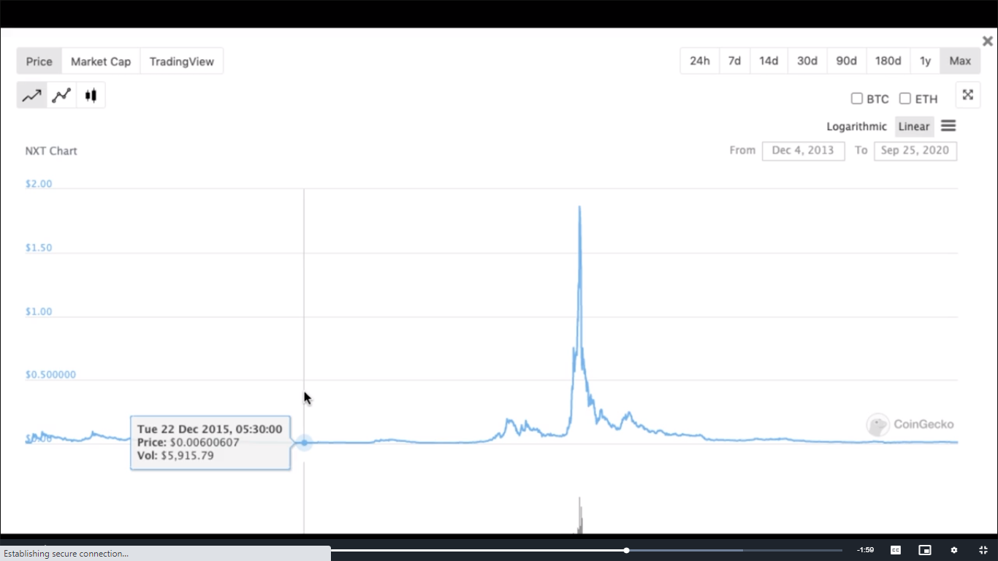

If you study the chart closely, you will understand why I chose this particular cryptocurrency to demonstrate the Pump-and-Dump strategy.

NXT is famous for having made the most gains from its ICO compared to any other.

Its investors made profits as much as 128,000x their investments.

This means if you had put in Re 1, you would have been able to get returns as high as Rs 128,000.

Now, if you observe this chart carefully, you will be able to see the exact point where the coin started being pumped and started its ascent.

It reaches its peak and then immediately drops back down, right around the point from where it started growing.

This can be seen as a classic example of a pump-and-dump cycle.

There is always a possibility that this trend might repeat itself, although it is not entirely certain.

As a rule, you should try and stay away from assets with such cycles as you might end up losing money.

Once a stock has been through its pump-and-dump cycle, it is not likely that it will have a significant increase in its value.

However, if you are in the early stage of the cycle, where the asset is still being hyped up, you can for sure enter the market and make considerable gains.

Just be sure to get out in time.

**PS:** This strategy requires a keen eye and an experienced hand. If you are a novice in this field, I would advise you against this approach as it is extremely risky.

## **Cyclic Stocks**

In simple terms, a cyclic stock is one that keeps repeating its pattern.

Its price is essentially stuck in a loop and keeps echoing itself.

Since its trend keeps repeating, it is easy to recognize the best time to enter and exit the market.

Simply buy at the bottom of the cycle and sell as soon as you near the top.

Chances are high in such stocks that the price pattern will remain the same which is why they can be very profitable to you.

If you do not want to be an active investor and only wish to play the market a couple times a year, cyclic stocks are the way to go.

## How To Invest In Cyclic Stocks

**Look for repetitive patterns:** As the name suggests, these are stocks whose patterns continue to repeat themselves. If a specific pattern has repeated itself four times in a row, it is safe to assume that it is going to repeat itself yet again. You will definitely be needing a keen eye to look out for cyclic stocks.

**Buy in reversal stage:** This is very simple. Since you already know which way the price is going to go, you can plan your market entry and exit points accordingly. Buy in reversal stage of the cycle, that is, when it is at its lowest and sell once it is near its approximate highest point.

**Don’t target new highs:** It is good to be ambitious and take certain risks. However, with cyclic stocks, it is best you ride the wave with which you are already familiar. There are always chances that the price may go up but this is an unnecessary risk to take.

**Can hold in corrections:** You can hold cyclic stocks in corrections. Since we already know the price trend for the stock, even in case of an early correction, you can be assured that the stock will follow its existing trend and the price will go up.

However, please remember that these stocks are a sure bet until they are not. As soon as the trend stops repeating itself, there are chances that you might end up losing money.

Let us now study a cyclic pattern to understand it in further detail.

Given below is the performance graph for Dogecoin.

I have been successfully investing in this digital coin for the past several years because of its repeating patterns.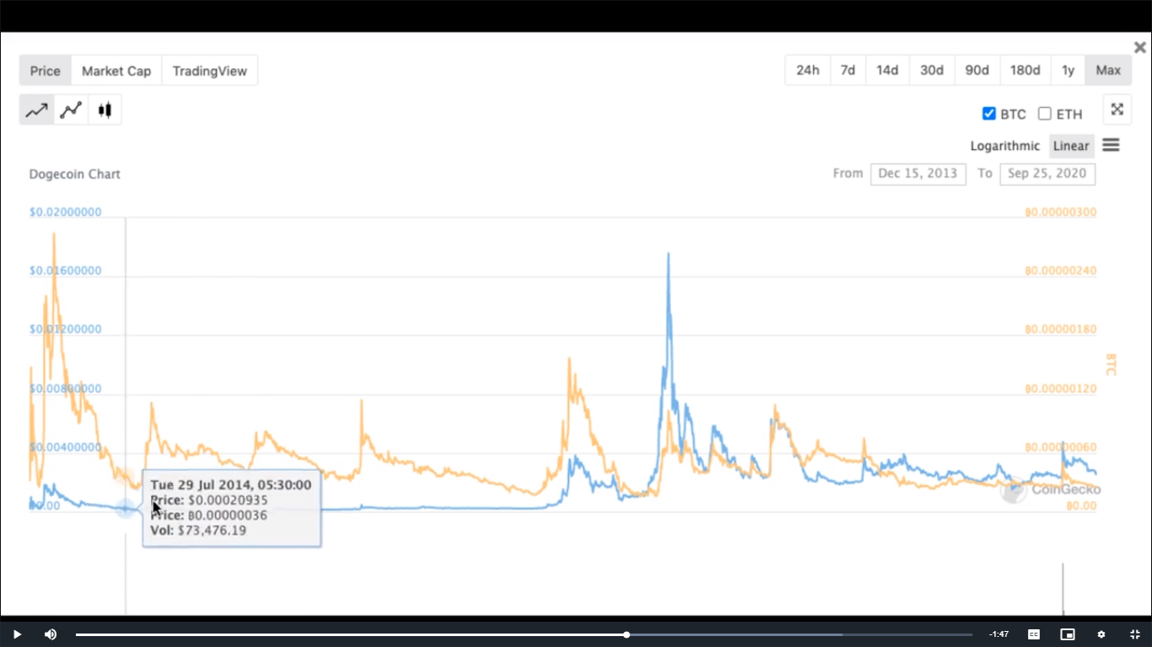

The Dogecoin is a classic example for a cyclic stock.

In the graph given, the blue line represents Dogecoin and the orange line represents Bitcoin.

Speaking in terms of Bitcoin, whenever the coin starts nearing 30 Satoshis (0.00000030BTC), its price goes up and reaches approximately 100 Satoshis (0.00000100BTC) before declining.

Whenever I invest in Dogecoin, I buy in the range of 25-26 Satoshis and sell as the asset nears 80 Satoshis.

This investing approach has helped me increase my bitcoins a lot.

Because of its pattern, I do not look to reach new highs

So far, there have been seven such Dogecoin cycles and the coin always repeats its trend.

However, it has not reversed its ascent in a long time now as you can see in the graph above.

The blue line for our coin has not begun its descent since its last cycle.

I am currently holding Dogecoin and since I bought it at a nominal price, even if it falls, it will not hurt me as much.

This behaviour might be indicative of the end of this cyclic stock.

But as long as it does not break this cycle, you have to assume that it will eventually go back to its old habits.

This is just one example of cyclic stocks that I have given you.

With a little research, you will be able to find several similar digital assets where you will be able to make relatively safer bets.

However, as demonstrated in the graph above, a cyclic trend does not work like clockwork.

Even if it repeats its patterns, you still need to stay alert so you can buy-in at the lowest point possible and maintain your profitable position from previous cycles.

With this, I also conclude the topic on Short-term Investing Strategies.

## **Long-term Strategy**

As the name suggests, long-term strategies involve buying and holding coins for a long period of time without buying out or trading them.

If you are looking to invest in dominant cryptocurrencies, then a long-term approach is the way to go.

There are four essential points of note to remember about long-term investing:

1. Invest in fundamentally strong coins: If you are going to take the long-term approach, the only way to do it is by investing in dominant coins that have been around for a while. It is no use holding a new digital asset or one that is not strong fundamentally as more often than not, you will incur a loss. In order to take the long-term approach, go for coins like Bitcoin, Ethereum and the like.
2. Invest in coins you believe in: Unlike pump-and-dump, this is a strategy that requires an actual knowledge of the coins in which you are investing. Not all cryptocurrencies are the same; each one works differently. Therefore, it is important you know how a particular asset behaves before investing so you can develop an affinity for it. If you understand how it works, you will be better able to judge whether it is worth putting your money in or not.
3. Can stay invested through crashes and dumps: While with new and dubious cryptocurrencies, you have to constantly be on the lookout for an imminent crash in the market to jump ship, this is not the case here. In the long-term approach, you have your eye on the big picture because it will regain its value despite dips and crashes in the market.
4. Can prove to be a multibagger: If you are correct in your analysis of your coin and the market, it can prove to be a multibagger, that is, give you a return of over 100%. This means that there is a high chance for most of your long-term bets to fetch you a high yield. This is a very good feature unique to long-term investments.

A major difference between short-term strategy and long-term strategy is that in the latter, we always chase new highs.

Assets that are fundamentally strong and have a history of dominating the market are always assumed to be undervalued when they are being invested in.

This is because their value always increases in the long term.

Therefore, investors holding these coins are always chasing new highs.

Let’s study the performance graph of Ethereum to understand what a dominant coin is and how it behaves.

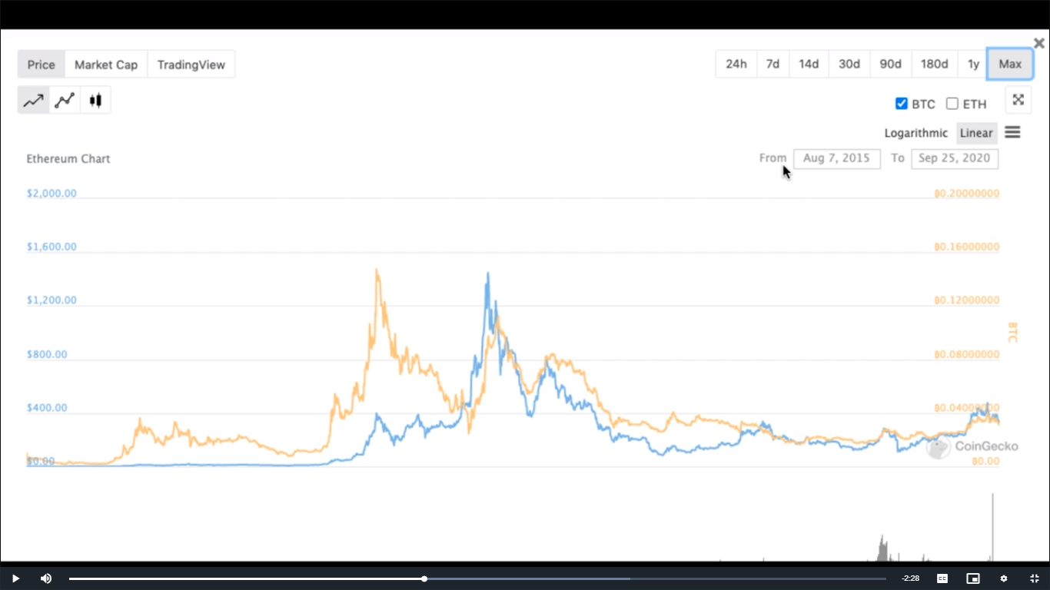

The blue line represents Ethereum and the orange line is for Bitcoin.

You can see that Ethereum’s price in the beginning was in mere cents, as represented by the almost flat line.

It took some time to match upto Bitcoin but gradually Ethereum started its ascent and since then it has not come even close to its base price.

This is a telling feature of a dominant asset―

Even though, in the short-run, it may go through a lot of ups and downs, in the long-term, its value always increases.

If you bought Ethereum at any time, you would not have to worry about losing any money if you were to invest for a long period of time.

This is also a multibagger asset as is evident from the graph above.

If you buy Ethereum at a fair valuation, that is, when it is below its mean position, you will be able to earn over 100% returns on your investment.

It is not uncommon for such assets to see a dip of 80%-90% in their price.

This does not mean that the coin has lost all its value.

If a coin has increased by 10,000x, it is normal for its price to see a notable fall from its peak.

You do not have anything to worry about until a dominant coin goes back to its base value, that is, from where it started out.

## **Cashing Out**

So far, we have discussed the two types of investing strategies in detail.

Let us now move on to another important aspect of investing, that is **cashing out**.

Cashing out of a market is as necessary as buying into it.

Timing plays an important role in this process.

There are a few things to keep in mind about cashing out of your investment.

### **Keep Making Partial Cashouts**

You should always have partial cashouts even if you believe a runup is still possible.

Runup refers to a sudden increase in the price of a stock.

Irrespective of whether a coin has the capacity to increase in value, you must remember that the market in itself is still volatile; anything can happen within seconds.

Therefore, even if there are chances that an asset might increase in value, always continue making partial cashouts, that is keep cashing out a small percentage of your investment from time to time.

This benefits you two-ways.

Firstly, you will hedge your risk.

Secondly, you will have liquid cash that you can invest further, if you come across a good enough opportunity.

I follow a simple rule when making partial cashouts.

I cash out my capital at 2x pump.

Simply put, as soon as my investment doubles up, I cash out my capital amount in a relatively stable currency.

### **Which Currency To Cash-out In?**

Another important decision to make now is the currency in which you should cash-out.

You have four options here:

* **BTC**
* **ETH**
* **USDT**
* **INR**

Let us understand the difference between these four currencies.

### **Bitcoin (BTC)**

The original cryptocurrency, Bitcoin is the most stable digital asset out there. Holding bitcoins never hurts investors as they only grow in value over the years. If you are invested in Bitcoin forks, it is profitable to cash-out in BTC.

### **Ethereum (ETH)**

When it comes to a strong ecosystem, Ethereum takes the cake. Ether has come up as the single, most-fearsome competitor of Bitcoin. It is also good to convert your investment into if you are using Uniswap.

### **Tether (USDT)**

If you do not want to hold any more Bitcoin, Ethereum or any other altcoins, but do want to be able to enter the crypto market in the future, Tether is a great option for you. Tether is a stablecoin which means its value is pegged to the US dollar. There won’t be a lot of movement in its value so you can hold them for a long period of time without any worry. This will also eliminate the need for you to constantly enter and exit the crypto market.

### **Indian Rupee (INR)**

If you feel like you no longer want to make additional investments in the crypto market and move on to other assets like gold or real estate or want to liquify your funds, you can simply convert them in INR and exit the market.

### **Manage Risk Portfolio**

Maintaining your portfolio is as important as creating one.

You must manage your risk portfolio as per the market conditions.

If the market is on a bearish run, it is better for you to hold stable currencies as the one mentioned above and lessen your risk as much as you can.

These are a few important points to note when cashing out of the crypto market.

## **Investing In ICO**

Let us now talk about ICOs: **Initial Coin Offering.**

Just like IPOs, an ICO is done by a company when it takes its cryptocurrency public for the first time.

To explain this in detail, I will be taking the example of Lukso.

**Disclaimer: This analysis is purely for educational purposes. Through this analysis, I only intend on demonstrating the parameters on the basis of which you should judge an ICO.**

Lukso provides NFT (Non-Fungible Token) solutions to brands, innovators and creatives.

NFT has garnered a lot of hype for itself at this point since it is deemed an interesting idea.

You can create your public profiles and issue digital certificates to prove your ownership of a token.

You can also create cultural currencies, that is, tokens that have become synonymous with interest, status, participation, and value on a global scale.

Lukso’s creators are Fabian Vogelsteller and Marjorie Hernandez.

Fabian is a blockchain expert who was an integral part of the Ethereum Foundation during its initial years.

His list of accomplishment in the field of blockchain and cryptocurrency is vast.

Helping shape the Ethereum space, creating the official Ethereum wallet, and the first decentralized web3 Browser are just a few from his vast list of accomplishments.

But perhaps his greatest exploit is the ERC-20 token, the token standard that started the ICO wave and the DeFi movement.

Needless to say, Fabian Vogelsteller is a well-received name in the crypto space.

Marjorie is an innovation and product expert.

Her training in architecture, innovation consultancy and strategy were key forces that helped her build and lead EY’s Innovation Lab in Berlin.

She has worked in Art Direction in Europe and has established herself as a brand strategist for Swiss and German brands.

While managing the EY Innovation Lab, she worked closely on Ethereum.

Her background as an entrepreneur and a designer, combined with her early relationship with Ethereum made a perfect combination of qualities required to lead Lukso.

The second and most interesting fact about Lukso for me is its advisory board.

Lukso’s advisors are top-tier officials from several major brands and companies from all over the globe.

Dr Ana Trbovich (Co-founder, Grid Singularity & Energy Web Foundation), Andrea Abrams (Co-founder, International Retail & Brand Expert Interconnected LLC), Dr Berndt Hauptkorn (President of Europe, Chanel), Daniel Heaf (VP Digital, Nike), Rajeev Aikkara (VP Digital Technology, Burberry)―these are just five from the 21-member advisory board of the company.

Now that we have discussed Lukso’s platform and its founders, let us move onto its tokennomics.

It has a current market cap $7.8 million and projects a final market cap of $70.9 million.

It has a total supply of 100 million LYXe, out of which 11,113,877 are already in circulation.

Lukso aims to have a supply of 45 million LYXes at its initial launch in the first quarter of 2021.

This is virtually nothing when we compare it to a good project.

There is a lot of room for Lukso to grow right now.

Lukso has also introduced **Reversible ICO**, which is exactly like it sounds.

Instead of buying LYXe at once, its Reversible ICO allows you to “save” a certain amount of the tokens.

These tokens will be purchased throughout an eight-month period at your initial commitment price.

At any time, you can return LYXe that has not been bought and get your ETH back.

However, LYXe that have been unlocked cannot be returned.

Therefore, if after reserving your token, its value does not go up or you no longer want to stay invested, you can redeem the LYXe that have not been purchased to the rICO smart contract address and get corresponding ethers back.

This shows the confidence of the company in itself.

A LYX distribution chart is also mentioned on its website.

It maps out the issuance of the LYX token, with 5% reserved for founder and collaborators, 10% for private sale and 10% for the first batch of public sale amongst other specifications.

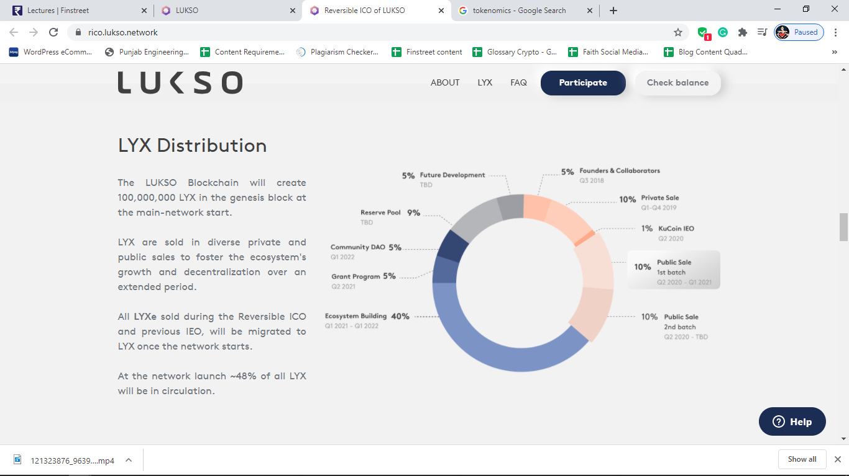

You can also read its whitepaper to understand the technology behind it.

It is largely based on Polkadot and is compatible with Ethereum.

It also has a lot of associations, a daily update of which you can get from its Twitter account.

Lukso is part of the Future Fashion Consumption panel, is listed on Kucoin and also have a good liquidity on Uniswap.

Lukso has also been building and engaging its community on Instagram to promote its ICO.

Its mainnet is yet to come.

You can, however, use its testnet which is live and experience it first-hand.

Lukso also has a mobile application which is another proof of its commitment towards its project.

Several major websites and creators, including Decrypt, Bloomberg and Altcoin Buzz have covered its project.

This was not a review of Lukso but merely the parameters that you should keep in mind before participating in an ICO.

In the past, there have been several cases of people being scammed by fake ICOs.

These events could easily have been avoided if a proper background check was done on the company.

Therefore, you should always do a thorough research beforehand whenever investing in an ICO so as not to be duped of your money.

## **Introduction To Technical Analysis**

Before you invest, you must do your research and conduct a proper analysis of the asset―this you have heard a lot by now.

So let us now talk about how exactly you should evaluate a coin.

There are two strategies to be used here: Fundamental and Technical.

Through fundamental analysis, you can figure out an asset’s intrinsic value by examining its economic and financial factors.

It looks for an asset’s real value.

On the other hand, technical analysis uses statistical trends to figure out which is the best asset to invest in.

While I lean more towards the fundamental analysis aspect, it is equally important to understand what technical analysis.

It is the perfect concoction of these two strategies that best help you decide which coin is the best.

### Definition

“Technical analysis is the analysis of the price movements in a market.”

Studying price movements can tell you a lot about a particular asset.

It was the performance history of NXT, Dogecoin and Ethereum that helped us determine what investing strategy to use with them for maximum yield.

There are three assumptions of technical analysis which are market discounts everything, price moves in trends and history repeats itself.

* **Market discounts everything:** The assumption here is that a market is irrational. Nothing in it is valued correctly. It is normal for an asset to be undervalued or overvalued than its intrinsic price. At some point, every asset in the market will be priced at a discounted value.
* **Price moves in trends:** We assume that the price of any asset moves in a trend. It is frequently observed that the price of a coin rises in the first week of a month and falls in the last week of the same month. If this happens frequently, it means that its price is moving in trends. There is a trend hidden in the performance of every coin. It is on you to sniff it out and use it to your advantage.
* **History repeats itself:** This assumption has a lot of real-world examples from the stock and crypto market. No matter how volatile a coin may be, on a macro level, it will always repeat its price movements.

Fundamental analysis can often prove to be a better option for predicting information flow or even outcomes.

Analysing a coin on a macro level can be better done through fundamental analysis.

It will tell you what the intrinsic value of an asset is and whether it is overvalued or undervalued.

Technical analysis is a trading discipline employed to evaluate investments and identify trading opportunities in price trends and patterns seen on charts.

The goal is to find a pattern in your investments to find the best opportunity to trade coins.

The process of studying the price movement of an asset and using it to make high-yielding investments is called technical analysis.

Technical analysts believe past trading activity and price changes of a security can be valuable indicators of the security’s future price movements.

These analysts firmly believe in the history and study past trends for indications of a security’s performance in the future.

Technical analysis may be contrasted with fundamental analysis, which focuses on a company’s financials rather than historical price patterns or stock trends.

The two approaches have polar opposite DNA.

While fundamental analysis uses financial reports, technical analysis ignores all this and completely focuses on an asset’s past trends.

It is very important to set a particular mindset when conducting the technical analysis.

You must act on the assumption that history will always repeat itself and study an asset’s past trends to figure out if it is worth investing in or not.

The good thing about this approach is that you don’t necessarily need to have a fundamental understanding of a cryptocurrency.

All you need are graphs of its past performance to predict its future.

## **Types Of Chart**

Let us begin with charts.

There are several types of charts that are used to portray the performance of a coin.

A proper knowledge of these graphs and the ability to read them correctly can help you a great deal in deciding which digital asset to invest in.